**Practical File**

of

**Fundamentals of C Programming**

**(24CSE0107)**

**Batch-2024**

**Bachelor of Engineering (CSE)**

|  |  |
| --- | --- |
| **Submitted By** Khushpreet kaur  Roll No. 2410991357  Group No. 17, Sem: 2nd, BE (CSE)  Chitkara University, Punjab, 140401,India | **Submitted To**  Dr. Arjun Puri  Assistant Professor, CSE  Chitkara University,Punjab 140401,India. |

**Department of**

**Computer Science and Engineering,**

**Chitkara University School of Engineering and Technology,**

**Chitkara University, Punjab, India**

**Index**

|  |  |  |
| --- | --- | --- |
| **Sr. No.** | **Experiment** | **Page No.** |
| 1 | Install C compiler (GCC/Code::Blocks), set up IDE, compile and run the first "Hello, World!" program | 3 |
| 2 | Write a Program to show the use to input (Scanf)/output (Printf) statements and block structure of C-program by highlightingthe features of &quot;stdio.h&quot;. | 4 |
| 3 | Write a program to add two numbers and display the sum. | 5 |
| 4 | Write a program to calculate the area and the circumference of a circle by using radius as the input provided by the user | 6 |
| 5 | Write a Program to perform addition, subtraction, division and multiplication of two numbers given as input by the user. | 7 |
| 6 | Write a program to evaluate each of the following equations. (i) V = u + at. (ii) S = ut+1/2at**2 (iii) T=2*a+√b+9c (iv) H=√b**2 +p**2 | 8-10 |
| 7 | Write a program to swap two variables:  a) By using temporary variable.  b) Without using temporary variable | 11-12 |
| 8 | Write a Program to find the greatest among three numbers using:  1. Conditional Operator  2. If-Else statement | 13-14 |
| 9 | Write the following statement by using switch case statement:  1. To check that an input alphabet is vowel or consonant.  2.to check whether a number is positive,negative or zero | 15-16 |
| 10 |  |  |
| 11 |  |  |
| 12 |  |  |
| 13 |  |  |
| 14 |  |  |
| 15 |  |  |
| 16 |  |  |
| 17 |  |  |
| 18 |  |  |
| 19 |  |  |
| 20 |  |  |
| 21 |  |  |
| 22 |  |  |
| 23 |  |  |
| 24 |  |  |
| 25 |  |  |
| 26 |  |  |
| 27 |  |  |
| 28 |  |  |
| 29 |  |  |
| 30 |  |  |
| 31 |  |  |

**Experiment No. 1.**

**Aim:**Install C compiler (GCC/Code::Blocks), set up IDE, compile and run the first "Hello, World!" program.

**Concept Used:** The concept used in this program includes the #include <stdio.h> directive to include the standard input-output library for functions like printf(). The main() function serves as the entry point, and the printf() function is used to display "Hello, World!" on the screen. The return 0; statement indicates successful execution of the program.

**Program**:

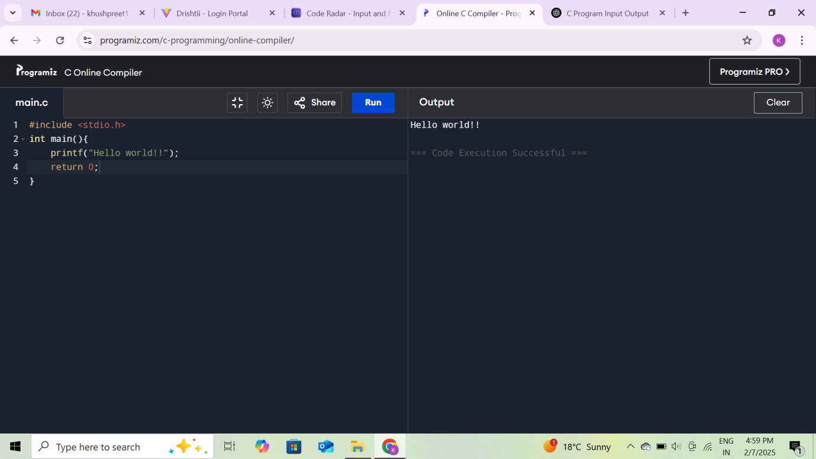

**Output Screenshot:**



**Experiment No. 2.**

**Aim:** Write a Program to show the use to input (Scanf)/output (Printf) statements and block structure of C-program by highlightingthe features of &quot;stdio.h&quot;.

**Concept Used:** The concept involves using the **stdio.h** library in C, which provides essential functions like **printf()** for output and **scanf()** for input. The program demonstrates how to read data from the user and display output by leveraging these functions. The block structure of C is illustrated by organizing the code inside the **main()** function, which serves as the entry point of the program. This setup highlights the proper use of input/output operations within the framework of a structured C program.

**Program**:

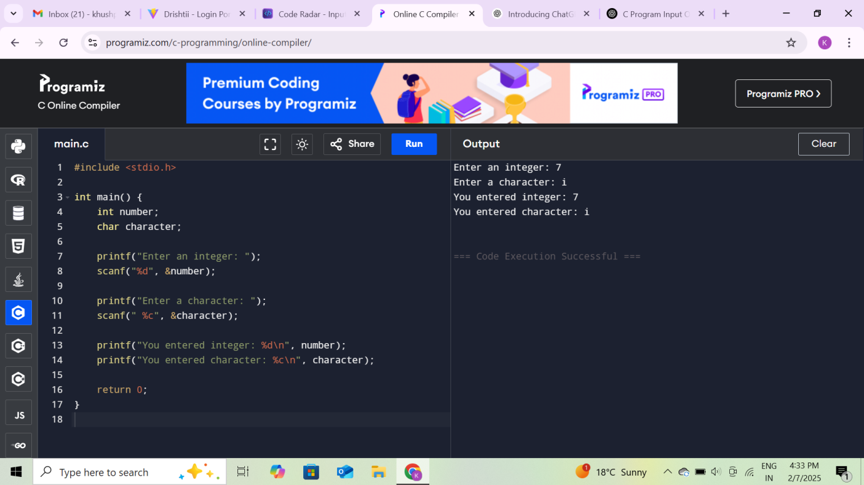

**Output Screenshot:**



**Experiment No. 3**

**Aim:** Write a program to add two numbers and display the sum.

**Concept used:** The concept involves performing basic arithmetic by reading two numbers from the user, adding them, and then displaying the result. The program is structured around the **main()** function, which acts as the entry point to execute the logic. The **stdio.h** library facilitates the process of handling input and output, supporting interaction between the program and the user. This demonstrates how to handle basic operations and communicate results in C programming.

**Program:**

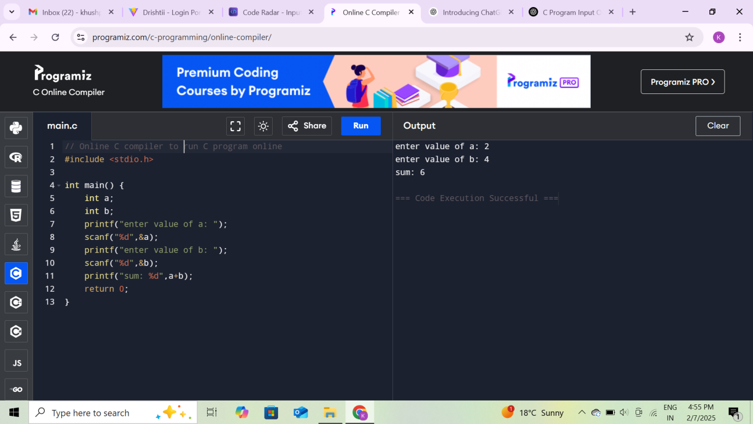

**Output Screenshot:**



**Experiment No. 4**

**Aim:** Write a program to calculate the area and the circumference of a circle by using radius as the input provided by the user.

**Concept used:** This program calculates the area and circumference of a circle using the radius input by the user. It uses basic arithmetic formulas: area = π * r² and circumference = 2 * π * r. The program utilizes stdio.h for input/output and math.h for the constant π. The logic is structured in the main() function, demonstrating simple mathematical operations and user interaction in C.

**Program:**

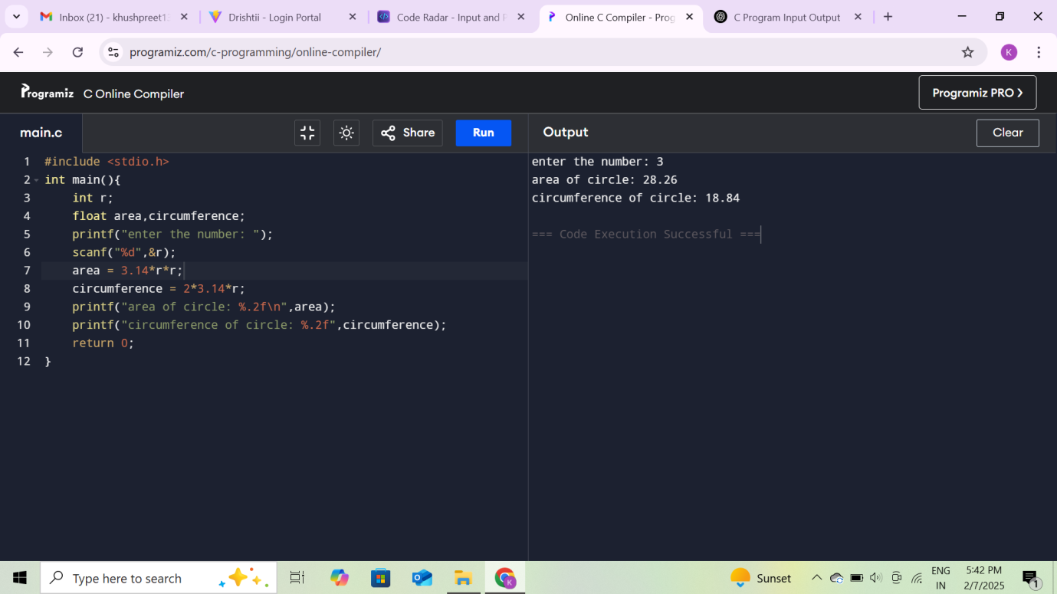

**Output Screenshot:**

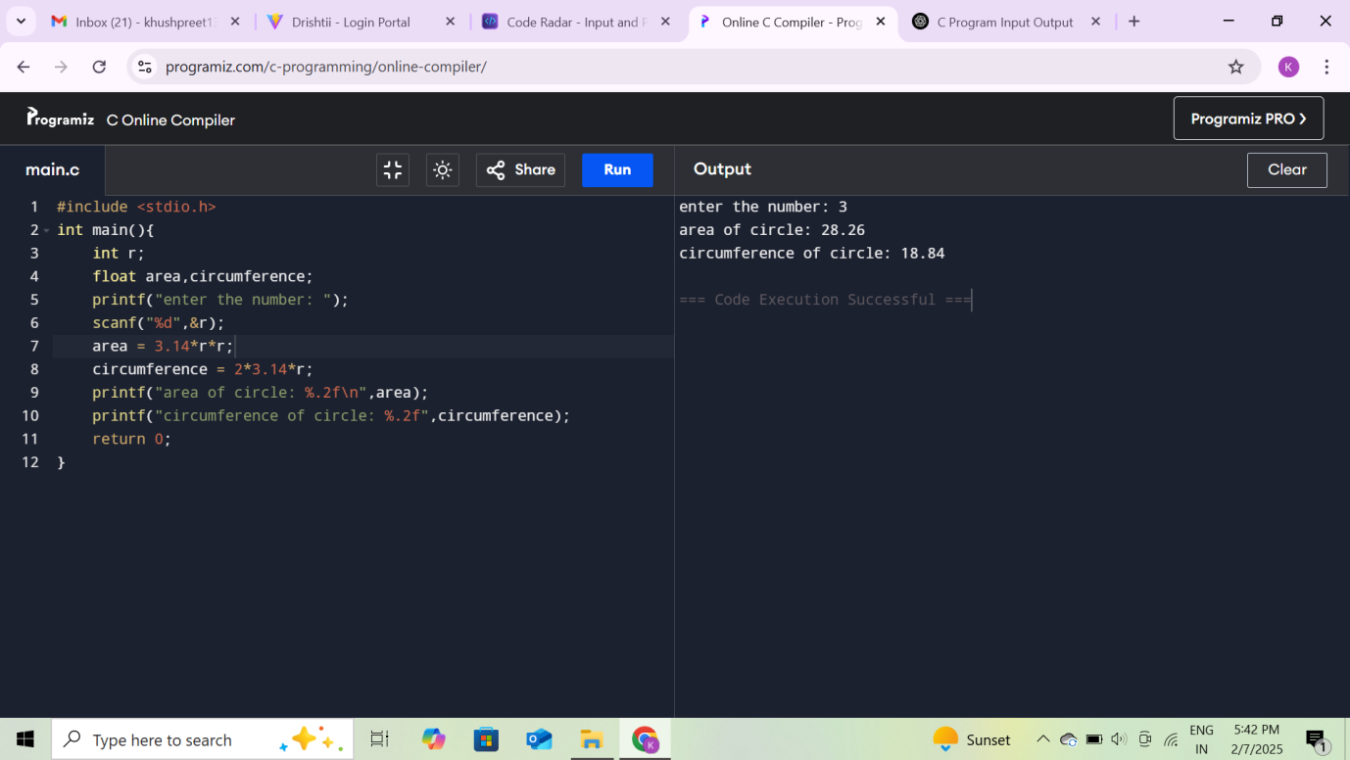

**Experiment No. 5**

**Aim:** Write a Program to perform addition, subtraction, division and multiplication of two numbers given as input by the user.

**Concept used:** This program reads two numbers and an operator from the user, then performs the corresponding arithmetic operation (addition, subtraction, multiplication, or division) based on the input. It uses **stdio.h** for input and output functions and applies **conditional statements** to check which operation to perform. The program also handles errors, such as division by zero, ensuring that invalid operations are flagged. This demonstrates basic input handling, arithmetic operations, and control structures in C programming.

**Program:**

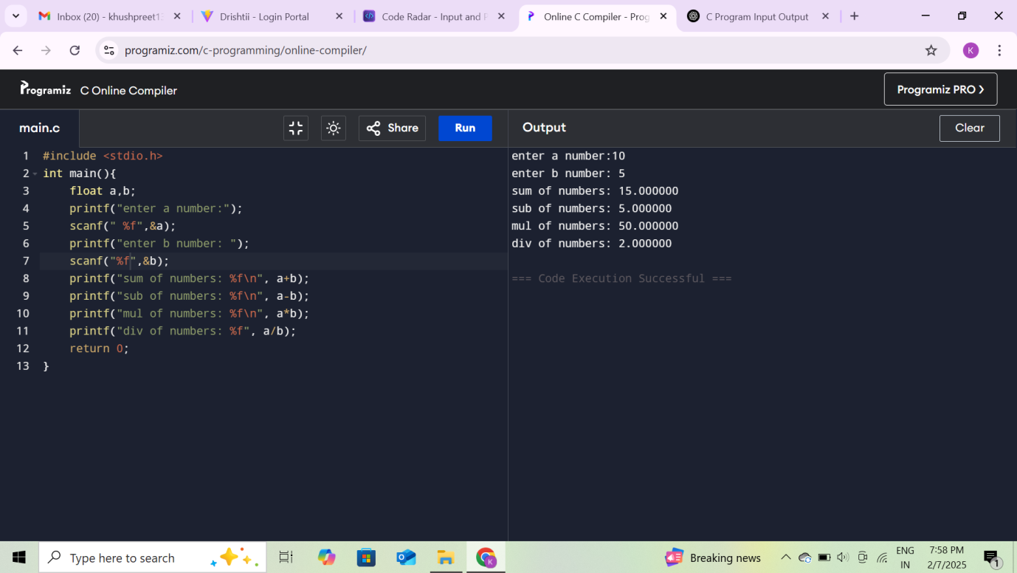

**Output Screenshot:**

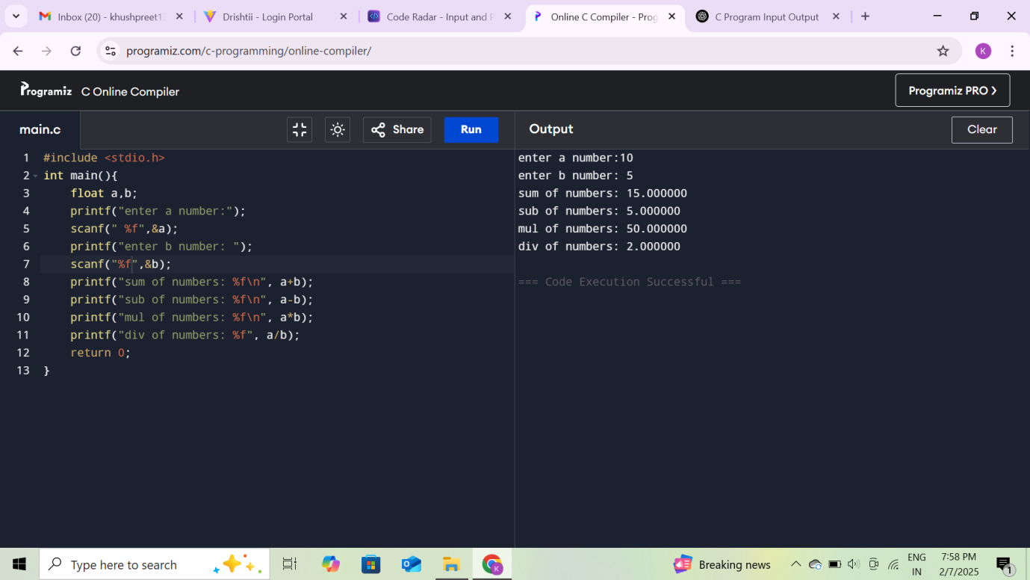

**Experiment No. 6**

**Aim:** Write a program to evaluate each of the following equations.

(i) V = u + at. (ii) S = ut+1/2at**2 (iii) T=2*a+√b+9c (iv) H=√b**2 +p**2

**Concept used:** This program calculates the values of four different equations based on user input, using basic arithmetic and mathematical operations. The program utilizes stdio.h for input/output functions and math.h for performing square root calculations. This demonstrates the use of variables, mathematical formulas, and user interaction in C programming.

**Program (i) V = u + at**

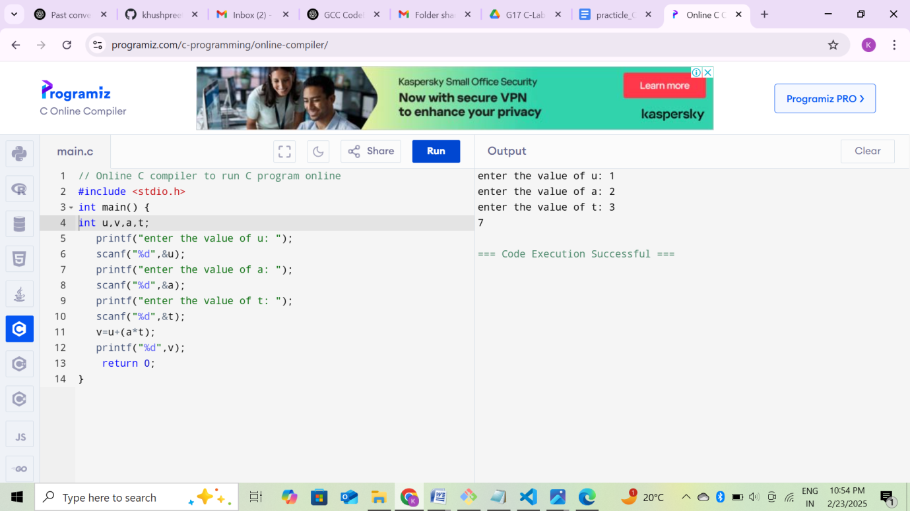

**Output Screenshot:**



**Program (ii) S = ut+1/2at**2**

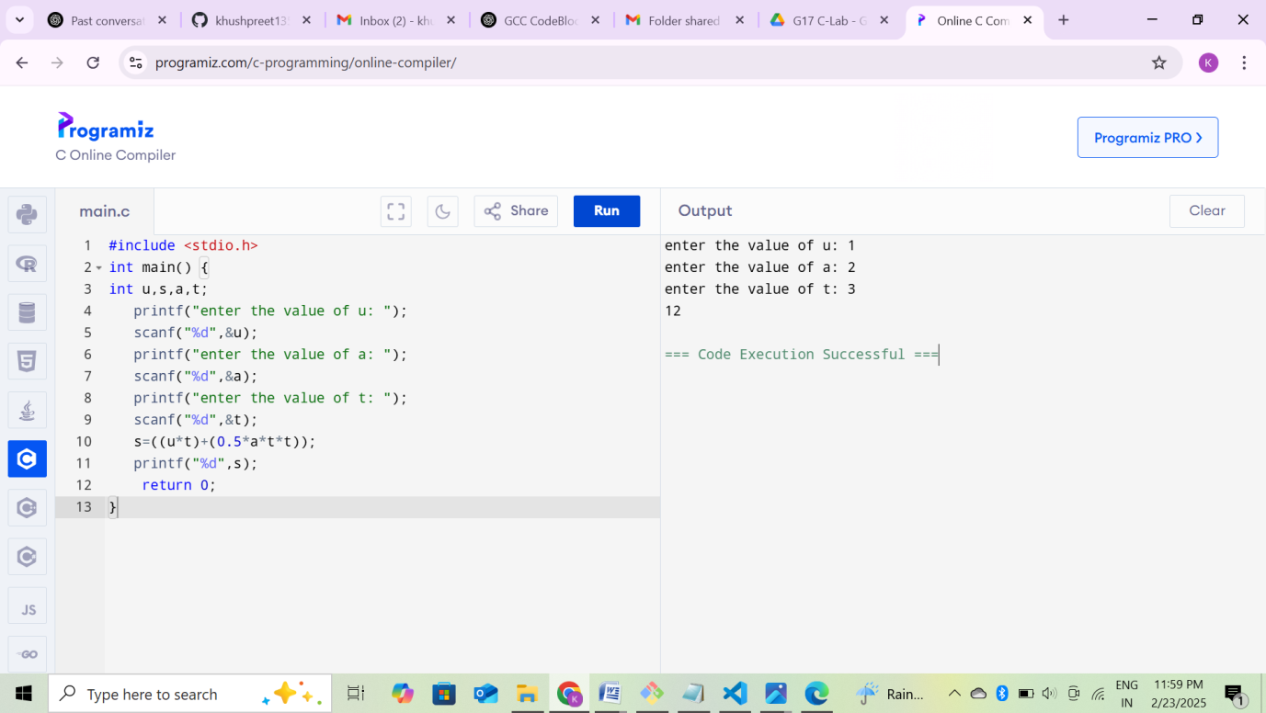

**Output Screenshot:**

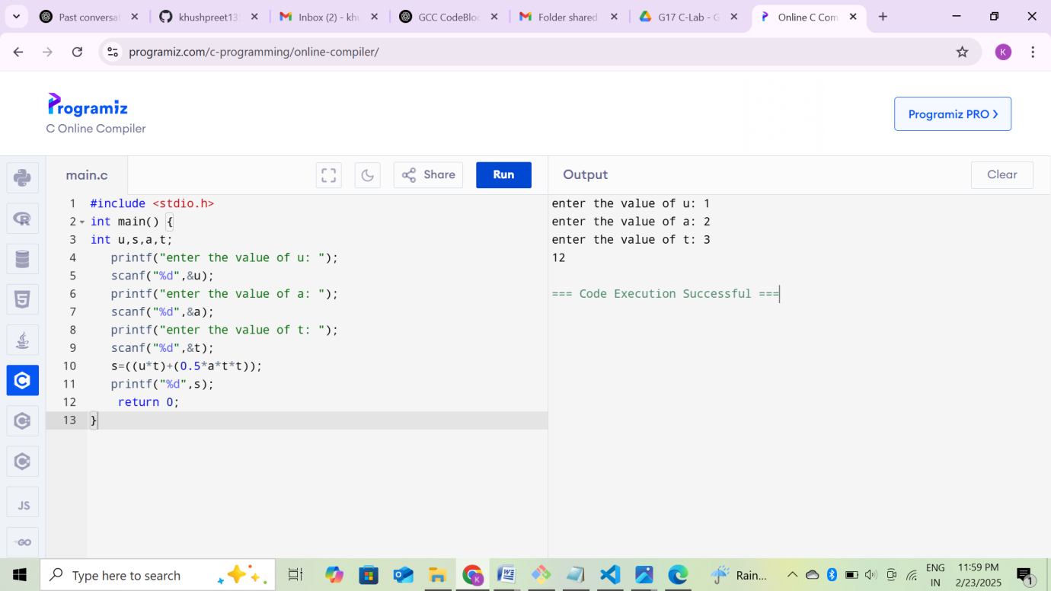

**Program (iii) T=2*a+√b+9c**

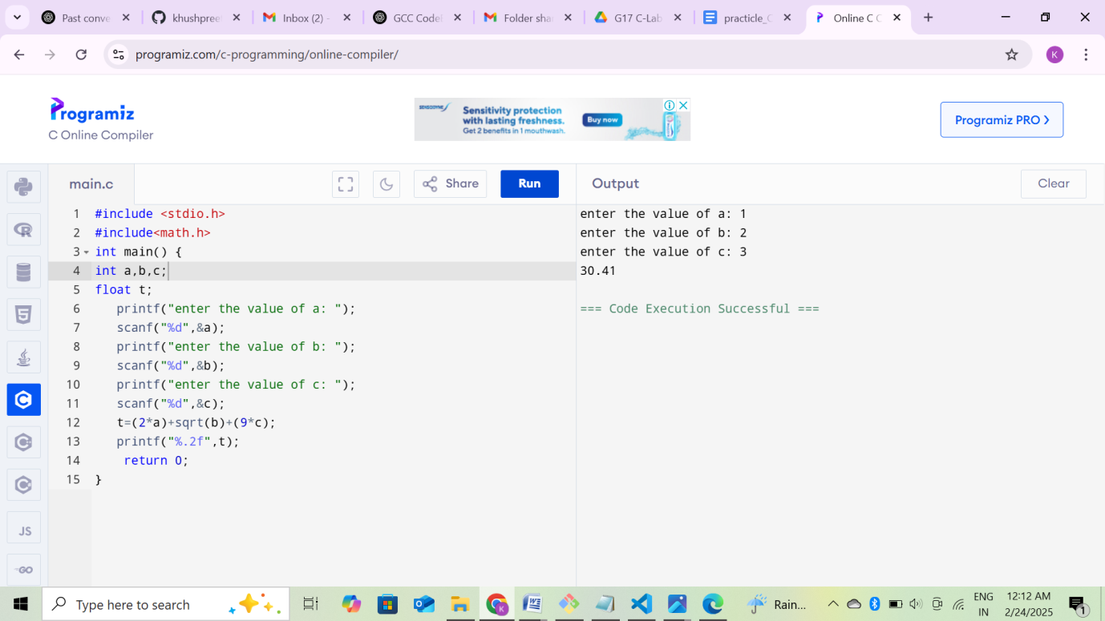

**Output Screenshot:**



**Program (iv) H=√b**2 +p**2**

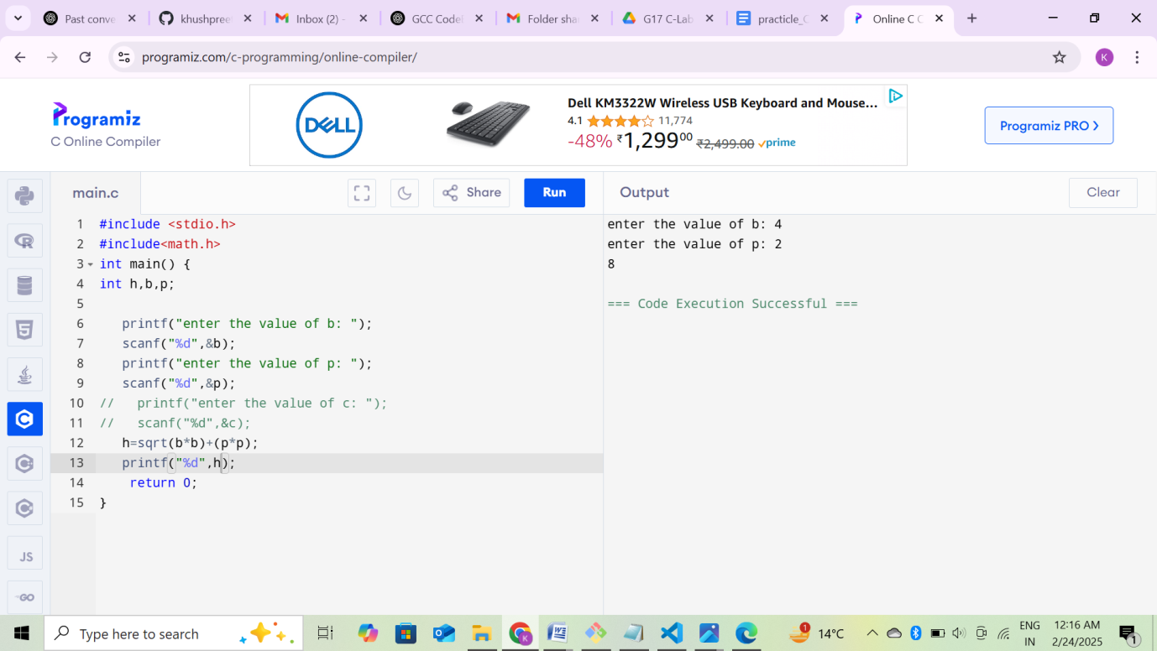

**Output Screenshot:**



**Experiment No. 7**

**Aim:** Write a program to swap two variables:

a) By using temporary variable.

b) Without using temporary variable

**Concept used:** Swapping can be done using a temporary variable by storing one value temporarily, or without it using arithmetic (addition/subtraction) or bitwise XOR operations. Both methods exchange values but differ in memory usage and computational complexity.

**Program:** a) By using temporary variable.

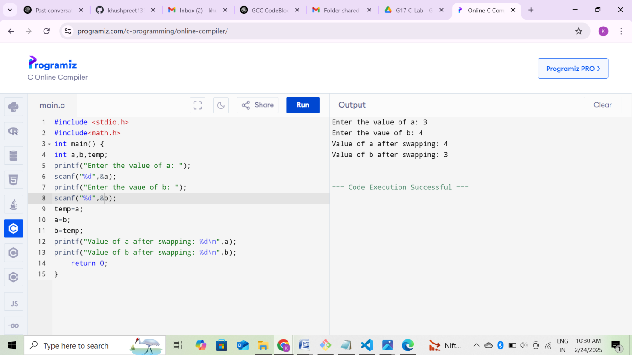

**Output Screenshot:**

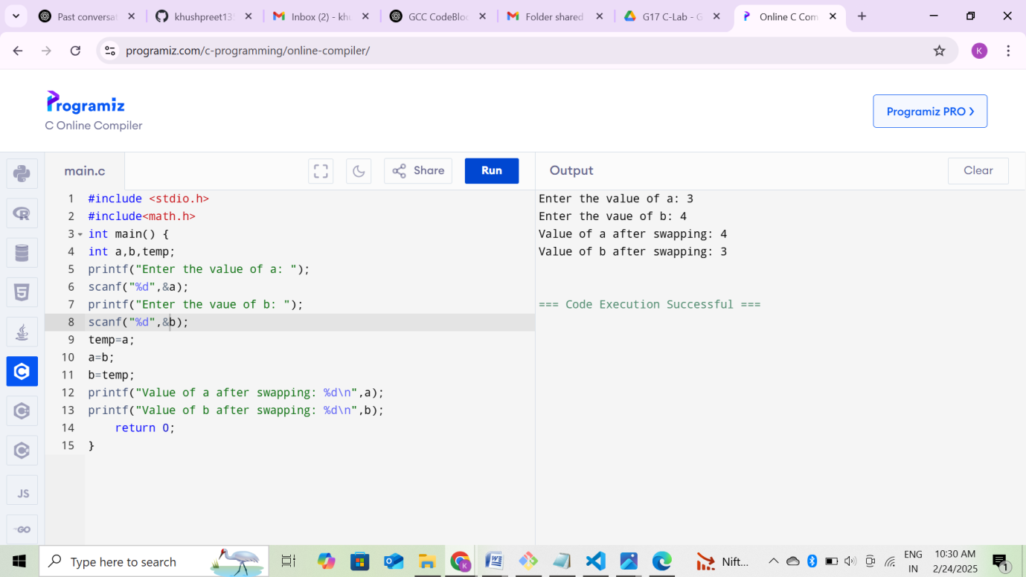

**Program:** b) Without using temporary variable

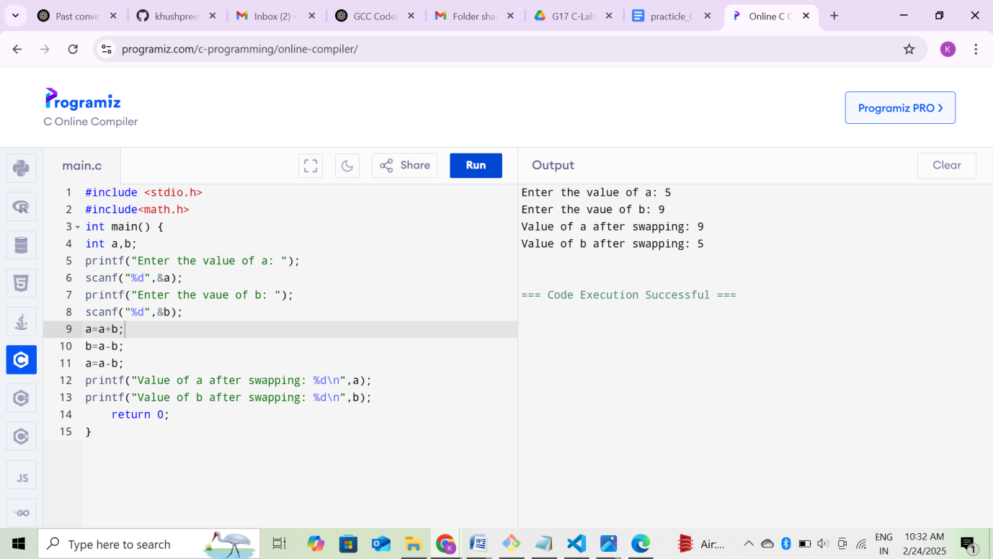

**Output Screenshot:**

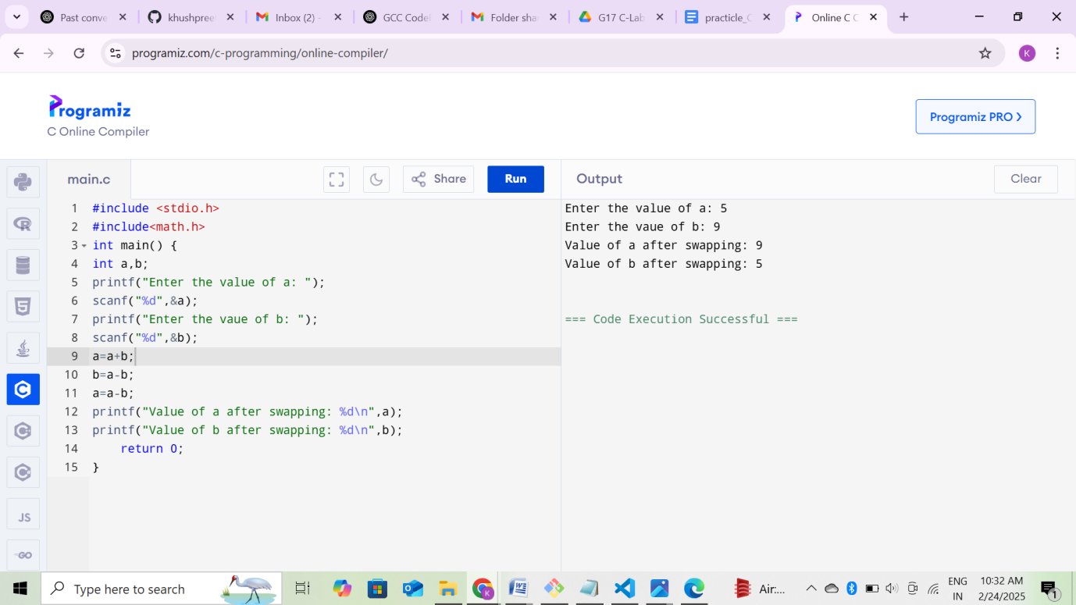

**Experiment No. 8**

**Aim:** Write a Program to find the greatest among three numbers using:

1. Conditional Operator

2. If-Else statement

**Concept Used:** To find the greatest of three numbers, we can use the **conditional operator** or **if-else statements.** The conditional operator compares the numbers in a single line, returning the greatest value based on conditions. The if-else method sequentially checks conditions to determine the largest number. Both approaches achieve the same result with different syntaxes.

**Program: 1. Conditional Operator**

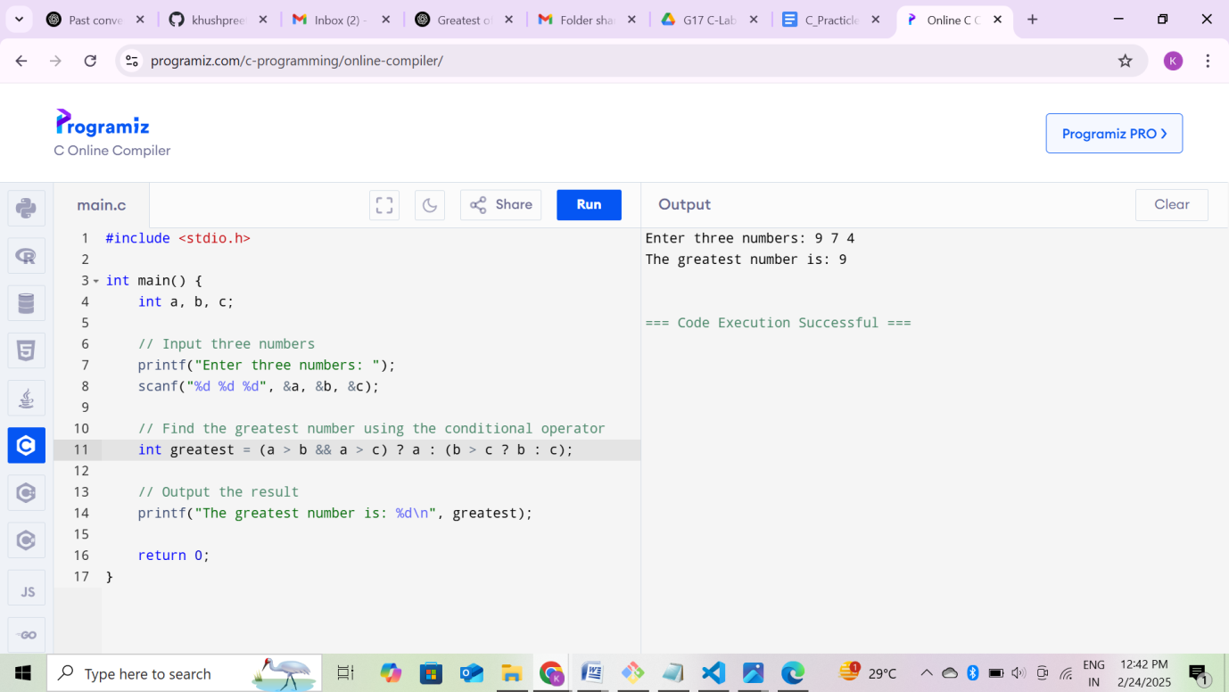

**Output Screenshot:**



**Program: 2. If-Else statement**

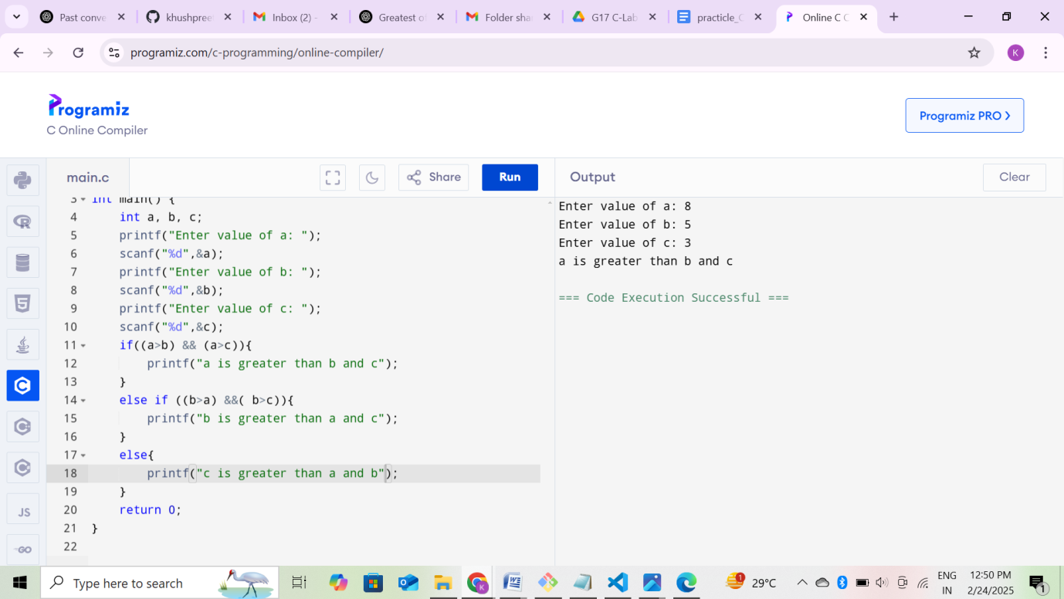

**Output Screenshot:**

